REPORT

DR. AMBEDKAR COLLEGE, DEEKSHABHOOMI, NAGPUR DEPARTMENT OF LAW

CELEBRATION OF CONSTITUTION DAY Date: 26TH NOVEMBER, 2018

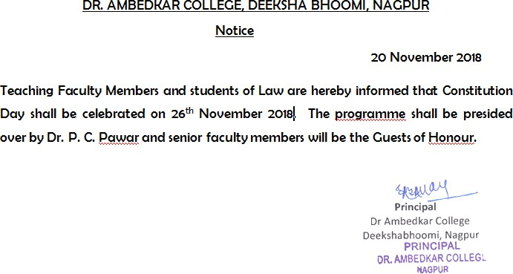

The Constitution Day was celebrated by Legal Aid Clinic of Department of Law, Dr. Ambedkar College, Deekshabhoomi, Nagpur on 26th November, 2018 with great enthusiasm to spread the awareness about the Indian Constitution and to instill the values of Constitution amongst the student. The programme began with the garlanding of the portraits of Thathagat Gautam Buddha and Parampoojya Dr. Babasaheb Ambedkar. The students of LL.B. 5 Y.C. and LL.B. 3 Y.C. and faculty gathered at the seminar Hall of the department of Law. HOD of Law Dr. N. M. Khirale addressed the students and explained the importance of Constitution of India. He had also highlighted the basic and fundamental aspects of Indian Constitution and appealed the students to preserve the spirit of integrity, humanism and social values enshrined in the Constitution of India. Dr. V.V. Deshpande, Dr. S.P.Kalamdhad and Dr. P.R. Lokhande were also present on the occasion.

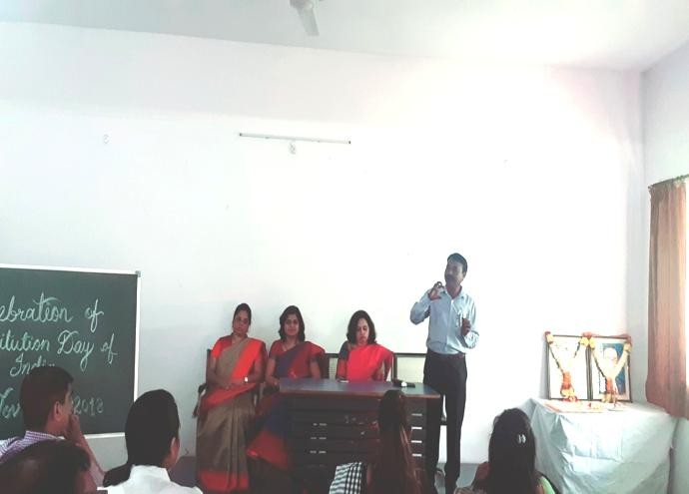

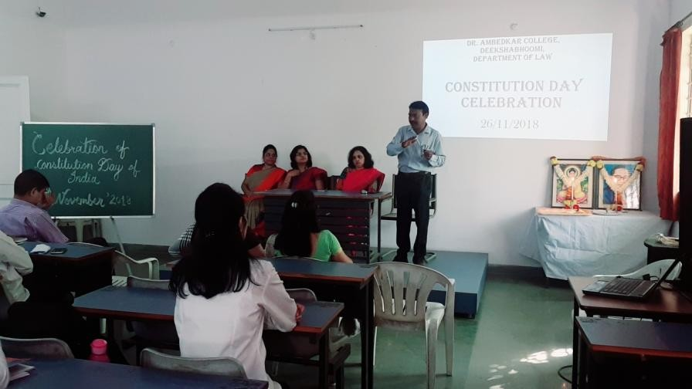

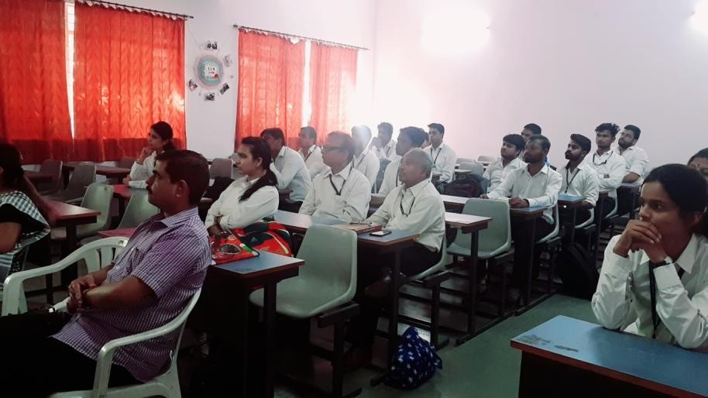

REPORT

FREE LEGAL AID AND LITERACY PROGRAMME DHAMMACHAKRA PRAVARTAN DIN ON 17, 18 AND 19TH OCTOBER 2018

Chief Guest : Dr. Sudhir Meshram, Former Vice Chancellor, North Maharashtra University, Jalgaon,
Guest of Honour : Shri. B.A. Sheikh, Judicial Member, State Consumer Forum, Nagpur Shri. N.R. Sute, Member of Param Poojya Dr. Babasaheb Ambedkar Smarak Samiti, Deekshabhoomi, Nagpur.

Free Legal Aid and Literacy Programme was organized by Department of Law on the occasion of Dhammachakra Pravartan Din on 17, 18 and 19th October 2018. Free legal Aid camp is that activity which inculcates among studentsto use their knowledge of law toprovide free legal aid to thousands of people who come to Deekhabhoomi on Dusshera. The programme was inaugurated at the Chief Guest, Dr. Sudhir Meshram, Former Vice Chancellor, North Maharashtra University, Jalgaon, and Shri. B.A. Sheikh, Judicial Member, State Consumer Forum, Nagpur. Dr. P. C. Pawar, Principal of Dr. Ambedkar College, Deekhabhoomi, Nagpur, and Shri. N.R. Sute, member of Param Poojya Smarak Samiti, also graced the occasion by their eminent presence.
In his address, Shri. B.A. Sheikh, the Guest of Honour, emphasized the need of empathy towards the society among the budding lawyers and encouraged them to apply noble principles while pursuingtheir profession. Dr. Sudhir Meshram, Chief Guest highlighted the importance of legal aid and also appreciated the cordialassociationbetween the faculty and the students of Department of Law. Dr. N.M. Khirale, Head of the Department in his speech motivated the student to take part in the legal aid camp and shared his 13 years of experience of conducting such camp.
The students of three years course and five years course actively and enthusiastically spread the word of awareness on different legal issues, during the camp under the supervision of faculties. A register is maintained wherein the details of people with legal problems is also noted by the students. The said programme was conducted by Mrs. Vaishali A. Sukhdeve and Ms. Shazia Bari, and Vote of thanks was given by Dr. Ms. Pratima Lokhande.

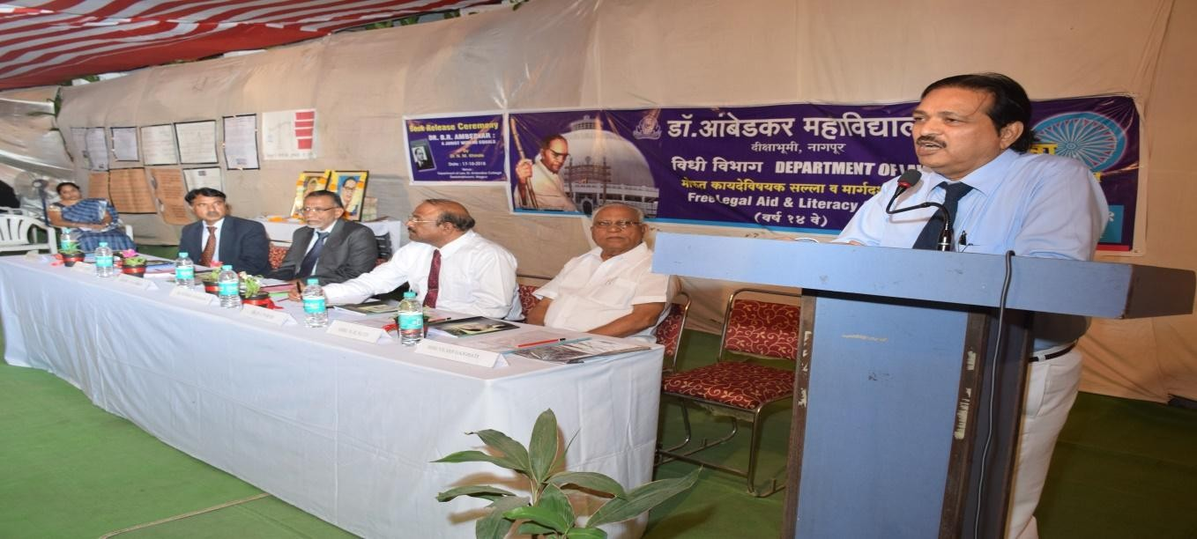

Dr. Sudhir Meshram, Former Vice Chancellor, North Maharashtra University, Jalgaon addressing the students.

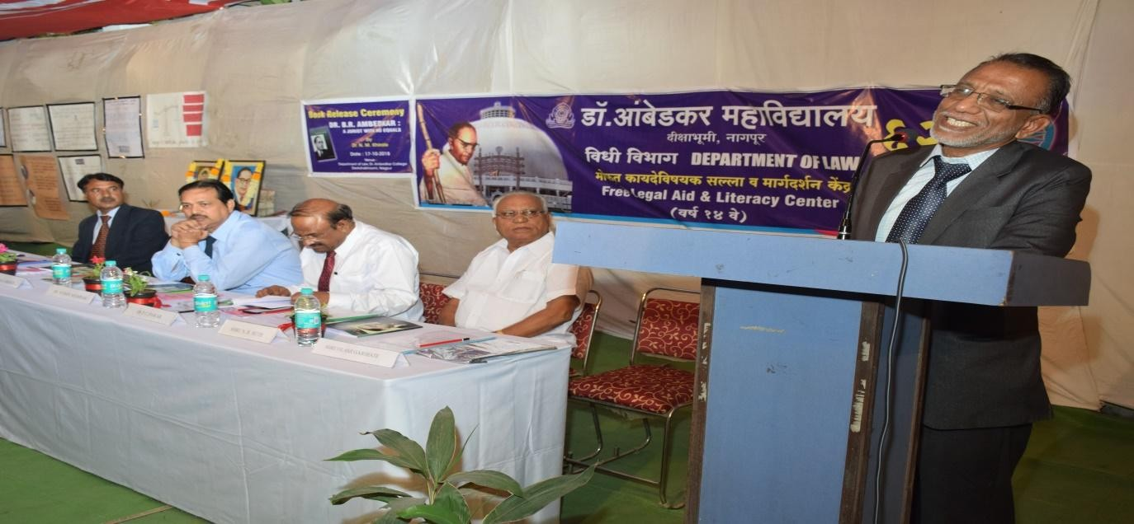

Shri.B.A. Sheikh, Judicial Member, State Consumer Forum, Nagpur, interacting with the audience.

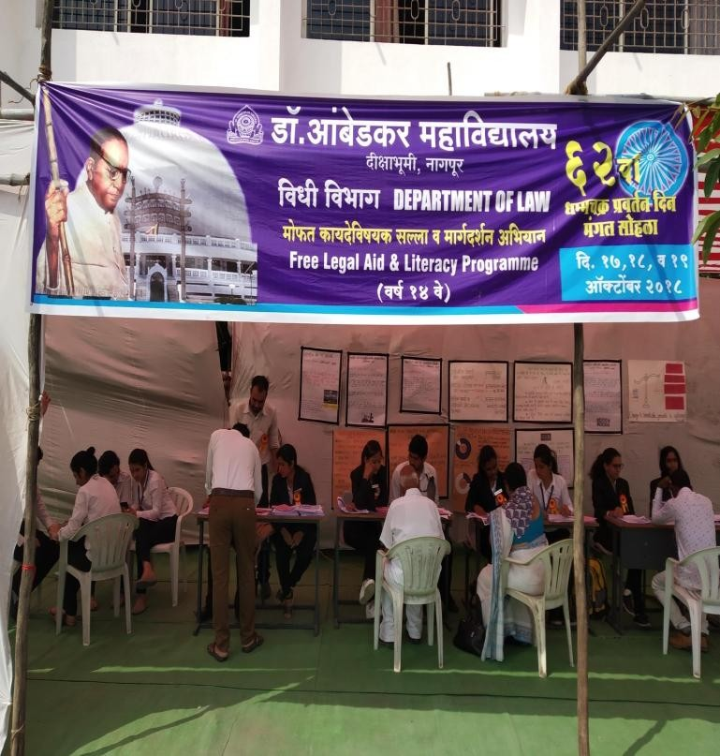
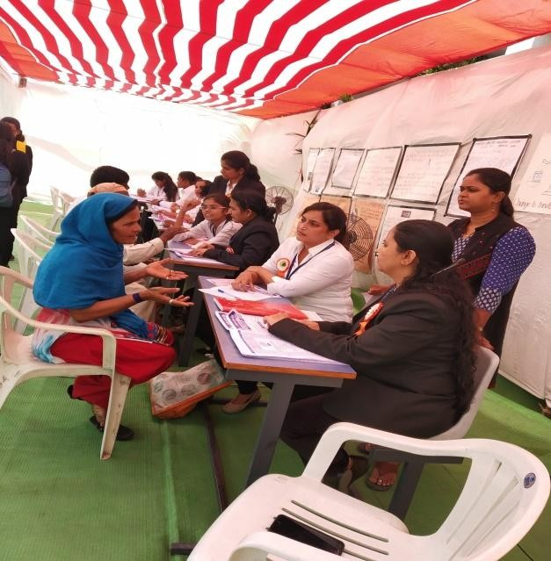
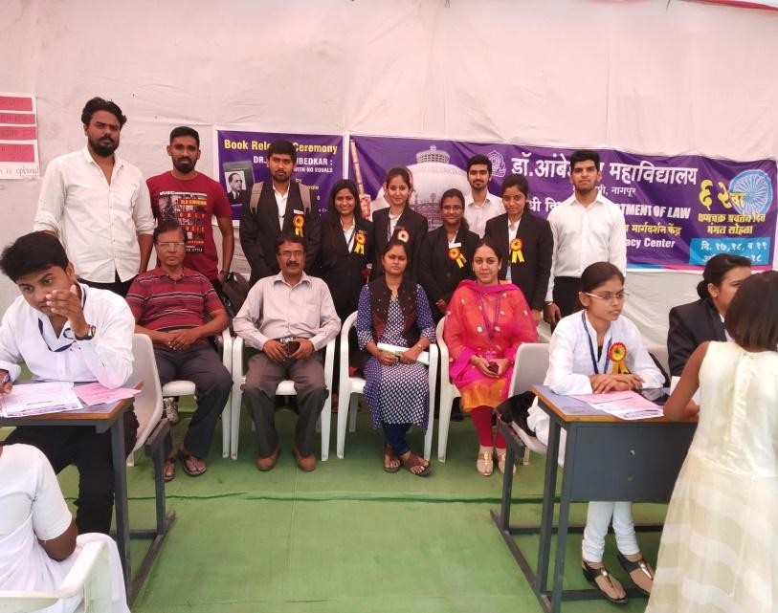

Students of LLB 5 years and 3 years interacting with the people and guiding them on legal issues

